BANK LOAN REPORT QUERY DOCUMENT

1. BANK LOAN REPORT | SUMMARY

KPI’s :

TOTAL LOAN APPLICATIONS:

SELECT COUNT(id) as Total_Loan_Applications From bank_loan;

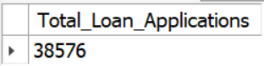

MTD LOAN APPLICATIONS:

SELECT COUNT(id) as MTD_Total_Loan_Applications from bank_loan

WHERE issue_date LIKE '%-12-%';

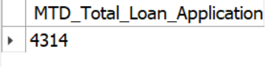

PMTD LOAN APPLICATIONS:

SELECT COUNT(id) as PMTD_Total_Loan_Applications from bank_loan

WHERE issue_date LIKE '%-11-%';

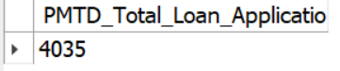

TOTAL FUNDED AMOUNT:

SELECT SUM(loan_amount) AS Total_funded_amount from bank_loan;

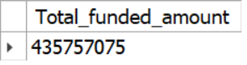

MTD TOTAL FUNDED AMOUNT:

SELECT SUM(loan_amount) AS MTD_Total_funded_amount from bank_loan

WHERE issue_date LIKE '%-12-%';

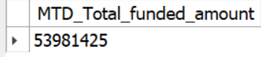

PMTD TOTAL FUNDED AMOUNT:

SELECT SUM(loan_amount) AS PMTD_Total_funded_amount from bank_loan

WHERE issue_date LIKE '%-11-%';

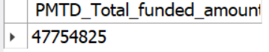

TOTAL AMOUNT RECEIVED:

SELECT SUM(TOTAL_PAYMENT) AS TOTAL_AMOUNT_COLLECTED FROM BANK_LOAN;

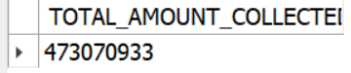

MTD TOTAL FUNDED AMOUNT:

SELECT SUM(TOTAL_PAYMENT) AS MTD_TOTAL_AMOUNT_COLLECTED FROM BANK_LOAN

WHERE issue_date LIKE '%-12-%';

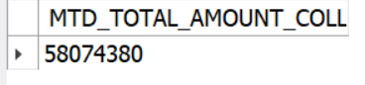

PMTD TOTAL FUNDED AMOUNT:

SELECT SUM(TOTAL_PAYMENT) AS PMTD_TOTAL_AMOUNT_COLLECTED FROM BANK_LOAN

WHERE issue_date LIKE '%-11-%';

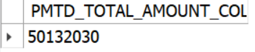

AVERAGE INTEREST RATE:

SELECT ROUND(AVG(INT_RATE)*100,2) AS AVG_INTEREST_RATE FROM BANK_LOAN;

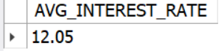

MTD AVERAGE INTEREST RATE:

SELECT ROUND(AVG(INT_RATE)*100,2) AS MTD_AVG_INTEREST_RATE FROM BANK_LOAN

WHERE issue_date LIKE '%-12-%';

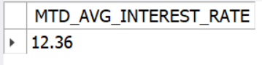

PMTD AVERAGE INTEREST RATE:

SELECT ROUND(AVG(INT_RATE)*100,2) AS PMTD_AVG_INTEREST_RATE FROM BANK_LOAN

WHERE issue_date LIKE '%-11-%';

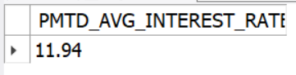

AVG_DTI

SELECT ROUND(AVG(DTI)*100,2) AS AVG_DTI FROM bank_loan;

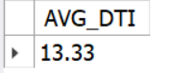

MDT AVG_DTI

SELECT ROUND(AVG(DTI)*100,2) AS MDT_AVG_DTI FROM bank_loan

WHERE issue_date LIKE '%-12-%';

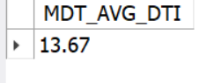

PMDT AVG_DTI

SELECT ROUND(AVG(DTI)*100,2) AS PMDT_AVG_DTI FROM bank_loan

WHERE issue_date LIKE '%-11-%';

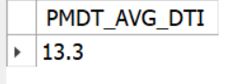

**GOOD LOANS ISSUED**

GOOD LOAN PERCENTAGE

SELECT (COUNT(CASE WHEN loan_status= 'Fully Paid' OR loan_status= 'Current' THEN id END ) * 100) /

COUNT(id) AS Good_loan_percentage

FROM bank_loan;

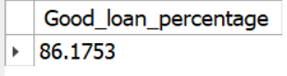

GOOD LOAN APPLICATIONS NUMBERS

SELECT COUNT(id) AS Good_Loan_Applications FROM bank_loan

WHERE loan_status IN ('Fully Paid','Current');

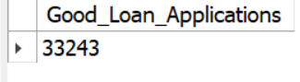

GOOD LOAN FUNDED AMOUNT

SELECT SUM(loan_amount) AS Good_Loan_funded_Amount FROM bank_loan

WHERE loan_status IN ('Fully Paid','Current');

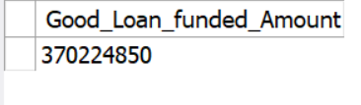

GOOD LOAN RECEIVED AMOUNT

SELECT SUM(total_payment) AS Good_Loan_Received_Amount FROM bank_loan

WHERE loan_status IN ('Fully Paid','Current');

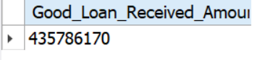

**BAD LOANS ISSUED**

BAD LOAN PERCENTAGE

SELECT (COUNT(CASE WHEN loan_status= 'Charged off' THEN id END)*100) /

COUNT(id) AS Bad_Loan_Percentage FROM bank_loan;

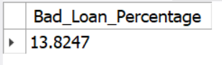

BAD LOAN APPLICATIONS NUMBERS

SELECT COUNT(id) AS Bad_Loan_Applications from bank_loan

WHERE loan_status='Charged off';

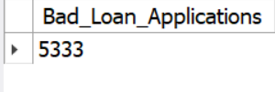

BAD LOAN FUNDED AMOUNT

SELECT SUM(loan_amount) AS Bad_loan_funded_amount FROM bank_loan

WHERE loan_status='Charged off';

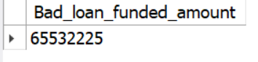

BAD LOAN RECEIVED AMOUNT

SELECT SUM(total_payment) AS Bad_Loan_received_amount FROM bank_loan

WHERE loan_status='Charged off';

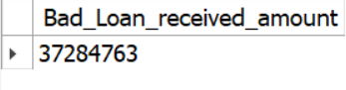

**LOAN STATUS**

SELECT loan_status,

COUNT(id) AS Total_Loan_applications,

SUM(loan_amount) AS Total_funded_Loan_amount,

SUM(total_payment) AS total_loan_amount_received,

AVG(int_rate)*100 AS AVG_Interest_rate,

AVG(dti)*100 AS AVG_DTI

FROM bank_loan

GROUP BY loan_status;

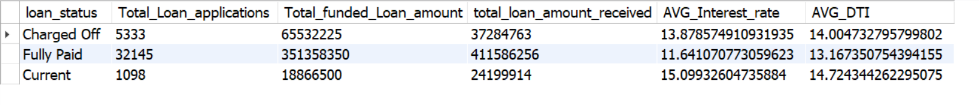

SELECT loan_status,

SUM(loan_amount) AS MDT_funded_amt,

SUM(total_payment) AS MDT_received_amt

FROM bank_loan

WHERE issue_date LIKE '%-12-%'

GROUP BY loan_status;

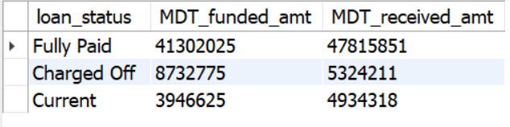

SELECT loan_status,

SUM(loan_amount) AS PMDT_funded_amt,

SUM(total_payment) AS PMDT_received_amt

FROM bank_loan

WHERE issue_date LIKE '%-11-%'

GROUP BY loan_status;

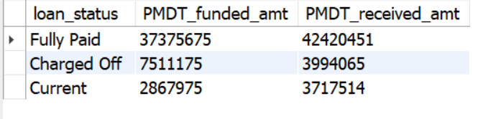

**BANK LOAN REPORT | OVERVIEW**

**MONTH**

SELECT MONTH(issued_date) AS S_Number,MONTHNAME(issued_date),COUNT(id) AS Total_Loan_Applications,

SUM(loan_amount) AS Total_Funded_amount,

SUM(total_payment) AS Total_received_amount

FROM bank_loan

GROUP BY 1,2

ORDER BY 1 ;

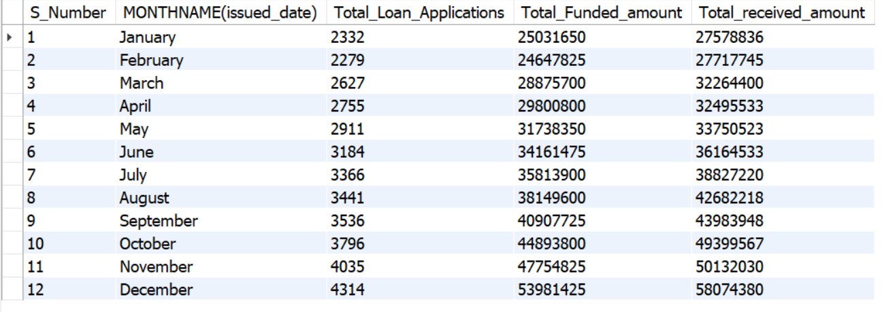

**STATE**

SELECT address_state AS State,

COUNT(id) AS Total_Loan_Applications,

SUM(loan_amount) AS Total_Funded_amount,

SUM(total_payment) AS Total_received_amount

FROM bank_loan

GROUP BY 1

ORDER BY 1 ;

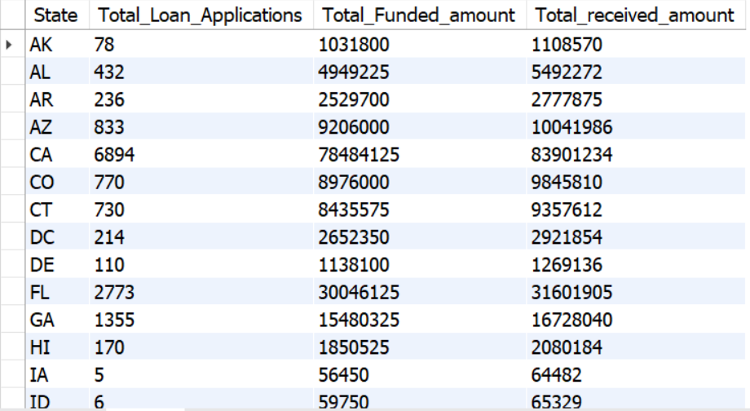

**TERM**

SELECT term,

COUNT(id) AS Total_Loan_Applications,

SUM(loan_amount) AS Total_Funded_amount,

SUM(total_payment) AS Total_received_amount

FROM bank_loan

GROUP BY 1

ORDER BY 1 ;

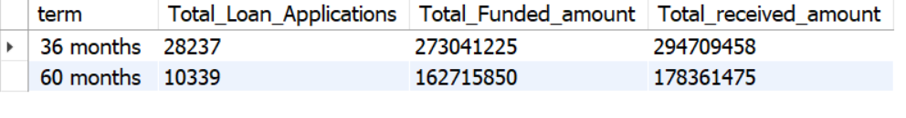

**EMPLOYEE LENGTH**

SELECT emp_length,

COUNT(id) AS Total_Loan_Applications,

SUM(loan_amount) AS Total_Funded_amount,

SUM(total_payment) AS Total_received_amount

FROM bank_loan

GROUP BY 1

ORDER BY 1 ;

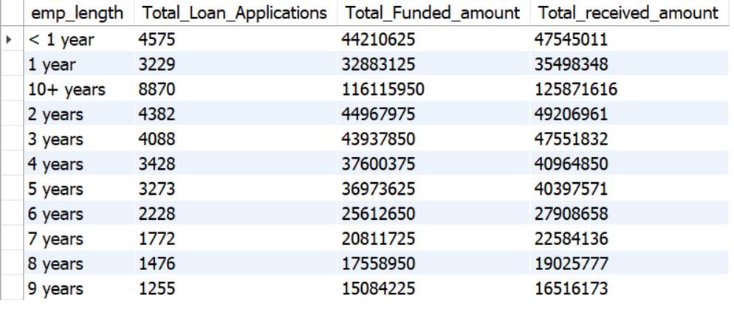

**PURPOSE**

SELECT purpose,

COUNT(id) AS Total_Loan_Applications,

SUM(loan_amount) AS Total_Funded_amount,

SUM(total_payment) AS Total_received_amount

FROM bank_loan

GROUP BY 1

ORDER BY 1 ;

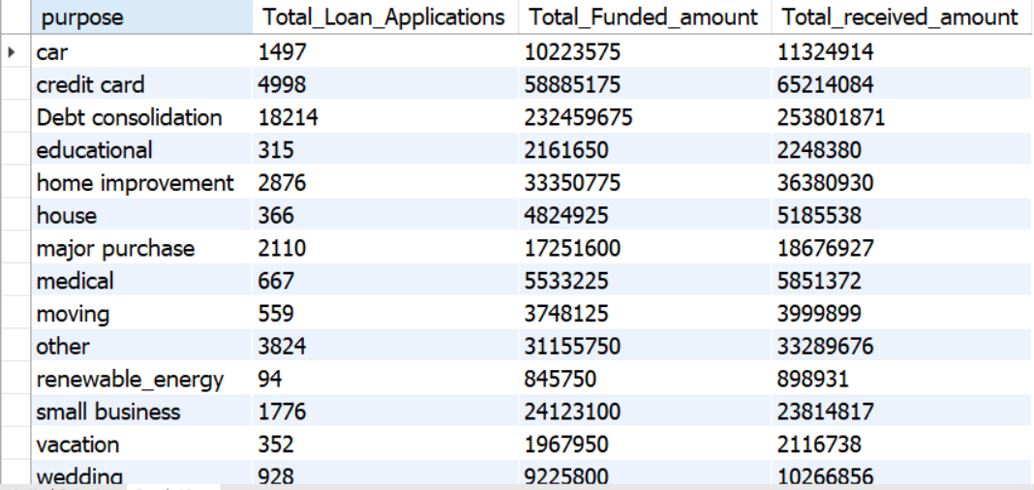

**HOME OWNERSHIP**

SELECT home_ownership,

COUNT(id) AS Total_Loan_Applications,

SUM(loan_amount) AS Total_Funded_amount,

SUM(total_payment) AS Total_received_amount

FROM bank_loan

GROUP BY 1

ORDER BY 1 ;

